Over the past two decades, advances in semiconductor technology have furthered progress towards a fully operational quantum computer. More specifically, the semiconductor well implementation of the fundamental building block of a quantum processor—the qubit—has seen huge improvements in scalability and performance.

The development of superior qubits is motivated by the vastly superior processing power of quantum computers. A modern consumer’s CPU contains roughly one billion transistors[5] that each correspond to a classical bit . Let ; the number of qubits required for a quantum processor to outperform a classical processor is[2]

Only 30 qubits are needed to match the performance! This reduction in information units has ramifications across all aspects of modern computing including security. A quantum computer programmed to use Shor’s Algorithm[6] can break modern encryptions in seconds while a classical computer could take years to perform the same operation.

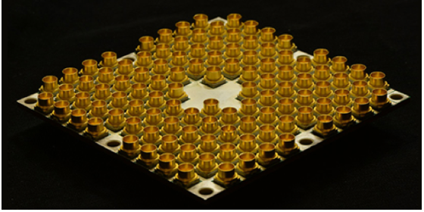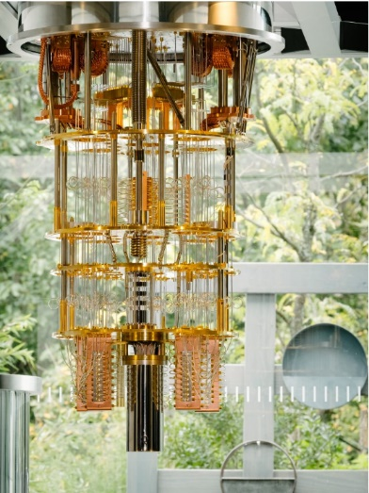Hardware and algorithm development for quantum computers is in its infancy, so the potential for quantum computers to change our world is both exciting and frightening. This has motivated research beyond academia, and companies including IBM, Intel, D-Wave, Google and Microsoft are racing to develop the hardware and algorithms to leverage this technology.

*Figure 1 – Adapted from [7]; left is IBM’s 50 qubit architecture, and right is Intel’s 49 Qubit lake processor. Both devices are strictly for research purposes, and they are laboratory-operated at temperatures below 4K. Many challenges must be overcome before either implementation sees commercial use over classical CPUs.*

Like a bit, a qubit can store information in a 0 or 1 state. However, quantum mechanics also enables the qubit to be in a *superposition* of both the 0 and 1 state. In very simplified terms, this means that a qubit can be in the state of 0, 1, or 0 *&* 1 *simultaneously*[1]. Quantum computing algorithms leverage the superposition and probabilistic properties of qubits to exponentially decrease computational complexity.

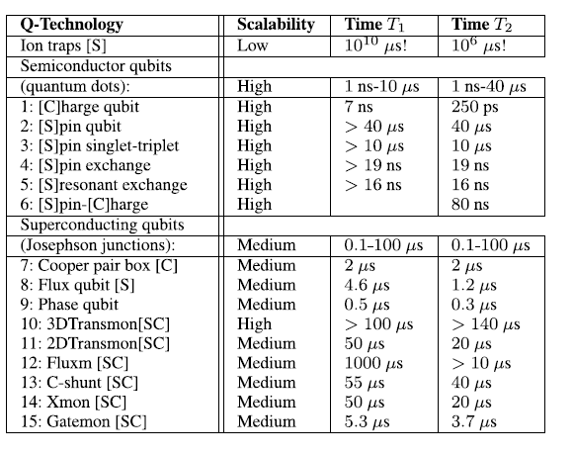Over the past two decades, multiple approaches of implementing physical systems of qubits have been attempted with varying degrees of success. Some of the more substantial implementations and their features are listed below.

*Figure 2 – Adapted from [3]; this table summarizes various technologies used to implement Qubits. The three primary categories of implementations are Ion Traps, Josephson Junctions (utilizing superconductors), and semiconductor quantum dots. [S] corresponds to an implementation using electron/hole spin, and [C] corresponds to an implementation using electron/hole charge. correspond to the decoherence time of the device.*

The two key parameters in this table are scalability and decoherence time. This survey will focus on recent implementations of semiconductor qubits, because they have shown the most promise in terms of scalability while maintaining reasonable decoherence times

Scalability describes the projected potential of the implementation to work with many more qubits. Scalability also factors in the possible integration of the qubits with current CMOS technologies[4]. Scalability is an extremely important design consideration as the end-goal of quantum-computing research is to have 100s, if not 1000s of qubits working together in a single, commercially-available system. To understand quantum dots, decoherence times, and the challenges of developing many-qubit architectures, a basic knowledge of some quantum mechanics postulates is required.

For any quantum mechanical system, all that can be known about the system is described mathematically by its wave function which obeys the Schrödinger equation.

In the case of a single-electron qubit, the system would be an electron confined within a quantum dot by potential . is Planck’s constant divided by , and is the *probability* *density* of the electron. This means that integrating over a region of space at a fixed point in time provides the chance of electron occupation.

On the macroscopic scale, electrons are essentially free to move anywhere. A quantum dot traps an electron (or other subatomic particle) within a region of space on the nanometer scale. Therefore, qubits are considered nanoelectronics devices and are often described as artificial atoms.

*Figure 3 – Visualization of a quantum dot. The blue dot represents the electron, and it is confined to a cubic region of space; the cube has a length, width, and height of L (nm).*

The solutions to the Schrödinger equation comprise of independent time and position components. Furthermore, the confinement imposed by the quantum dot causes the solutions to be quantized (discretized). The overall wave function can be written as a linear combination of these quantized solutions, and the result is that the electron can be described as the superposition

Modifying the physical properties of the quantum dot changes the number of terms in the superposition sum. A superposition of just two states— corresponds to 0, and corresponds to 1—matches the desired behavior of a qubit. For any quantum mechanical system, once a superposition is established, measuring the state of the system (*i.e* checking if the electron is state 0 or 1) will collapse the superposition into one of the individual states.

The decoherence time of a qubit describes the typical time before a superposition collapse occurs, and it is in direct conflict with the size and complexity of the system. The greater the complexity and outside interaction of a system, the more likely it is to collapse[1]. Therefore, as a system grows larger and has more qubits, maintaining long enough decoherence times such that computations can be fully completed is challenging.

Ion traps and Josephson junctions are intrinsically less scalable than semiconductor well implementations. They are significantly more expensive to operate (at ~15mK), and they do not support integration with current CMOS technologies[4]. Furthermore, Josephson Junctions’ decoherence times are fundamentally limited by the superconducting coherence length that is a measure of the Cooper pair size[3], and this is well below the demands of a computationally complex multi-qubit system. Ion traps can also impede qubit manipulation required for quantum computing calculations[1].

Real-world quantum dots are described by *finite*-potential well models[3], and a graphical description helps abstract the mathematical complexity to better illustrate the behavior of the electron.

*Figure 4 – adapted from [3], figure 4(a) shows the setup of a two-well system with boundary potentials . The two possible states of the qubit are a single electron occupying well 1 or occupying well 2 . The probability as a function of time is plotted in figure 4(b), and the discretized states are described in Bra-ket notation as and . Performing the finite-well derivation for confirms the probabilities. Furthermore, the probability is not a step function indicating a superposition of and .*

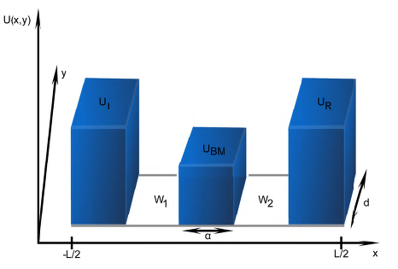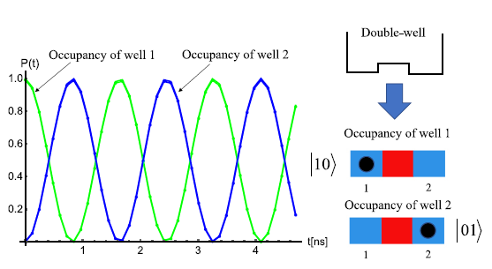

(a)

(b)

The qubit modeled in figure 4 uses electron occupancy in isolated potential wells (quantum dots) as the determining factor of the 0 or 1 qubit state. The measurement for this system is a complicated current or voltage measurement to determine the location of the single electron charge. Many factors limit the scalability of charge-based qubits[2], among which are the effects of nuclear spin, dephasing events, and occupancy oscillations[3]. These effects result in noise as seen in figure 5 below.

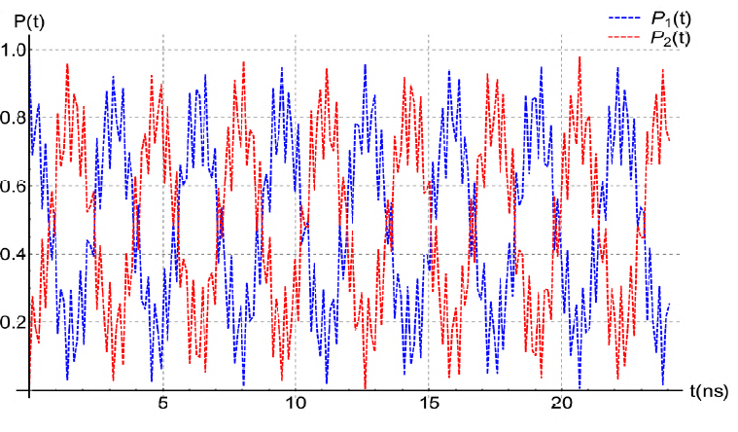 *Figure 5 – adapted from [3], this is analogous to figure 4 in that it shows the evolution of the probability of occupancy of the two wells over time. However, this figure accounts for the non-ideal effects of nuclear spin, occupancy oscillations, and dephasing events as noise.*

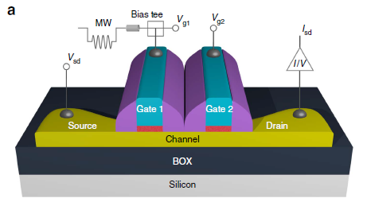 If the associated noise displayed in figure 5 grows too large, then the error in the quantum calculation becomes too large to be of any use. In terms of minimizing outside effects and increasing decoherence time, a more promising approach is the use of single electron’s spin down or up to represent the qubit’s 0 and 1 states. A spin-based qubit implementation using Silicon is shown below.

*Figure 6 – Adapted from [4], this is the schematic of the spin-based Silicon CMOS qubit. Charge accumulates beneath the gates, and this causes the formation of two quantum dots (red) in series beneath gate 1 and gate 2. The quantum dot beneath gate 1 contains the physical electron whose spin up/down determines the state of the qubit, and the quantum dot beneath gate 2 is used to measure the spin of the electron.*

Like charge measurements, dephasing events, nuclear spin, and occupancy oscillations also interfere with electron/hole spin measurements. Analytical methods including signal processing methodologies have been developed to minimize these effects[3].

Usage of Silicon is not nearly as mature as qubit constructions using GaAs (which date back to the early 2000s), but improvements in Silicon manufacturing including the reduction of impurities has redirected research efforts towards Silicon implementations. Researchers are continuing to explore the tradeoffs between the two materials, and Silicon is emerging as a promising base material for future spin-qubit implementations.

Continued research is needed before a fully-functioning quantum computer with 100s of qubits is fully realized. Current implementations of qubits using spin-based semiconductor quantum dots have shown promise in both scalability and decoherence time. A new era of computing can be ushered by this technology, and qubits are the foundation.

Works Cited

[1] Derbyshire, Katherine. “Introduction To Quantum Computing.” *Semiconductor Engineering*, 26 Apr. 2014, semiengineering.com/introduction-to-quantum-computing/.

[2] Eriksson, M.a., et al. “Semiconductor Quantum Dot Qubits.” *MRS Bulletin*, vol. 38, no. 10, Oct. 2013, pp. 794–801., doi:10.1557/mrs.2013.208.

[3] Giounanlis, Panagiotis, et al. “Modeling of Semiconductor Electrostatic Qubits Realized Through Coupled Quantum Dots.” *IEEE Access*, vol. 7, 4 Apr. 2019, pp. 49262–49278., doi:10.1109/access.2019.2909489.

[4] Maurand, R., et al. “A CMOS Silicon Spin Qubit.” *Nature Communications*, vol. 7, no. 1, 2016, doi:10.1038/ncomms13575.

[5] “Over 50 Years of Moore's Law.” *Intel*, Intel Corporation, [www.intel.com/content/www/us/en/silicon-innovations/moores-law-technology.html](http://www.intel.com/content/www/us/en/silicon-innovations/moores-law-technology.html).

[6] Shor, P.w. “Algorithms for Quantum Computation: Discrete Logarithms and Factoring.” *Proceedings 35th Annual Symposium on Foundations of Computer Science*, 20 Nov. 1994, doi:10.1109/sfcs.1994.365700.

[7] Sperling, Ed. “Quantum Computing Becoming Real.” *Semiconductor Engineering*, 6 July 2018, semiengineering.com/quantum-computing-becoming-real/.